**SQL PROJECT :- Library Management System**

Create a database named library and following TABLES in the database: 1. Branch 2. Employee 3. Books 4. Customer 5. IssueStatus 6. ReturnStatus Attributes for the tables: 1. Branch Branch_no - Set as PRIMARY KEY Manager_Id Branch_address Contact_no 2. Employee Emp_Id – Set as PRIMARY KEY Emp_name Position Salary Branch_no - Set as FOREIGN KEY and it refer Branch_no in Branch table 3. Books ISBN - Set as PRIMARY KEY Book_title Category Rental_Price Status [Give yes if book available and no if book not available] Author Publisher 4. Customer Customer_Id - Set as PRIMARY KEY Customer_name Customer_address Reg_date 5. IssueStatus Issue_Id - Set as PRIMARY KEY Issued_cust – Set as FOREIGN KEY and it refer customer_id in CUSTOMER table Issued_book_name Issue_date Isbn_book – Set as FOREIGN KEY and it should refer isbn in BOOKS table 6. ReturnStatus Return_Id - Set as PRIMARY KEY Return_cust Return_book_name Return_dateIsbn_book2 - Set as FOREIGN KEY and it should refer isbn in BOOKS table Display all the tables

CREATE DATABASE LIBRARY;

USE LIBRARY;

CREATE TABLE Branch(

Branch_No INT PRIMARY KEY,

Manager_Id INT,

Branch_Address VARCHAR(255),

Contact_No INT

);

CREATE TABLE Employee (

Emp_Id INT PRIMARY KEY,

Emp_Name VARCHAR(100),

Position VARCHAR(50),

Salary DECIMAL(10, 2),

Branch_No INT,

FOREIGN KEY (Branch_No) REFERENCES Branch(Branch_No)

);

CREATE TABLE Books (

ISBN INT PRIMARY KEY,

Book_Title VARCHAR(255),

Category VARCHAR(100),

Rental_Price DECIMAL(10, 2),

Status VARCHAR(3) CHECK (Status IN ('Yes', 'No')) NOT NULL,

Author VARCHAR(100),

Publisher VARCHAR(100)

);

CREATE TABLE Customer (

Customer_Id INT PRIMARY KEY,

Customer_Name VARCHAR(100),

Customer_Address VARCHAR(255),

Reg_Date DATE

);

CREATE TABLE IssueStatus (

Issue_Id INT PRIMARY KEY,

Issued_Cust INT,

Issued_Book_Name VARCHAR(255),

Issue_Date DATE,

ISBN_Book INT,

FOREIGN KEY (Issued_Cust) REFERENCES Customer(Customer_Id),

FOREIGN KEY (Isbn_book) REFERENCES Books(ISBN)

);

CREATE TABLE ReturnStatus

(

Return_Id INT PRIMARY KEY,

Return_Cust INT,

Return_Book_Name VARCHAR(255),

Return_Date DATE,

ISBN_Book2 INT,

FOREIGN KEY (Return_Cust) REFERENCES Customer(Customer_Id),

FOREIGN KEY (Isbn_book2) REFERENCES Books(ISBN)

);

INSERT INTO Branch(Branch_No, Manager_Id, Branch_Address, Contact_No)

VALUES

(1, 111, '123 Elm Street, New York, NY', 212555123),

(2, 222, '456 Maple Avenue, Los Angeles, CA', 323555234),

(3, 333, '789 Pine Road, Chicago, IL', 312555345),

(4, 444, '321 Oak Street, Houston, TX', 713555456),

(5, 555, '654 Cedar Avenue, Phoenix, AZ', 602555567);

INSERT INTO Employee (Emp_Id, Emp_Name, Position, Salary, Branch_No)

VALUES

(111, 'John Doe', 'Manager', 55000.00, 1),

(202, 'Jane Smith', 'Assistant Manager', 45000.00, 2),

(203, 'Michael Brown', 'Librarian', 40000.00, 3),

(204, 'Emily Davis', 'Clerk', 35000.00, 4),

(222, 'William Wilson', 'Manager', 56000.00, 5),

(206, 'Alice Johnson', 'Senior Librarian', 50000.00, 3),

(207, 'Bob Miller', 'Librarian', 42000.00, 3),

(208, 'Charlie Taylor', 'Assistant Librarian', 40000.00, 3),

(209, 'David Anderson', 'Clerk', 35000.00, 3),

(210, 'Eve Martinez', 'Janitor', 30000.00, 3),

(211, 'Michael Brown', 'Librarian', 42000.00, 2),

(212, 'Emily Davis', 'Clerk', 36000.00, 2),

(213, 'William Wilson', 'Janitor', 30000.00, 2),

(214, 'Olivia Taylor', 'Assistant Librarian', 40000.00, 2),

(215, 'James Anderson', 'IT Support', 45000.00, 2);

INSERT INTO Books (ISBN, Book_Title, Category, Rental_Price, Status, Author, Publisher)

VALUES

(1001, 'The C Programming Language', 'Programming', 25.99, 'Yes', 'Brian W. Kernighan Dennis M. Ritchie', 'Prentice Hall'),

(1002, 'Head First Java', 'Programming', 26.50, 'No', 'Kathy Sierra Bert Bates', 'O Reilly Media'),

(1003, 'The Great Gatsby', 'Fiction', 3.75, 'Yes', 'F. Scott Fitzgerald', 'Scribner'),

(1004, 'Introduction to Algorithms', 'Computer Science', 48.99, 'No', 'Thomas H. Cormen', 'MIT Press'),

(1005, '1984', 'Dystopian', 4.25, 'Yes', 'George Orwell', 'Signet Classics'),

(1006, 'The History of the Ancient World', 'History', 74.99, 'Yes', 'Susan Wise Bauer', 'W. W. Norton & Company'),

(1007, 'Guns, Germs, and Steel', 'History', 16.50, 'No', 'Jared Diamond', 'W. W. Norton & Company'),

(1008, 'The Silk Roads: A New History of the World', 'History', 22.25, 'Yes', 'Peter Frankopan', 'Vintage Books');

INSERT INTO Customer (Customer_Id, Customer_Name, Customer_Address, Reg_Date)

VALUES

(301, 'Alice Johnson', '789 Birch Lane, Seattle, WA', '2024-01-15'),

(302, 'Bob Miller', '456 Oak Drive, Austin, TX', '2024-02-10'),

(303, 'Charlie Taylor', '123 Pine Avenue, Boston, MA', '2024-03-05'),

(304, 'David Anderson', '321 Elm Road, Denver, CO', '2024-04-01'),

(305, 'Eve Martinez', '654 Cedar Street, Nashville, TN', '2024-05-12'),

(306, 'EMMA MARIA', '432 SAND FRANCISCO, USA', '2020-01-15'),

(307, 'TEKIE SEMAHAR', '775 JEBEL ALI, UAE', '2022-10-14'),

(308, 'JOHN LUKKA', '22 BLUE BERRY ROAD, CO', '2021-10-14');

INSERT INTO IssueStatus (Issue_Id, Issued_Cust, Issued_Book_Name, Issue_Date, ISBN_Book)

VALUES

(401, 301, 'The C Programming Language', '2024-06-01', 1001),

(402, 302, '1984', '2023-06-15', 1005),

(403, 303, 'Head First Java', '2024-07-01', 1002),

(404, 304, 'The Great Gatsby', '2023-06-10', 1003),

(405, 305, 'Introduction to Algorithms', '2024-08-01', 1004);

INSERT INTO ReturnStatus (Return_Id, Return_Cust, Return_Book_Name, Return_Date, ISBN_Book2)

VALUES

(501, 301, 'The C Programming Language', '2024-06-20', 1001),

(502, 302, '1984', '2024-06-25', 1005),

(503, 303, 'Head First Java', '2024-07-15', 1002),

(504, 304, 'The Great Gatsby', '2024-07-20', 1003),

(505, 305, 'Introduction to Algorithms', '2024-08-15', 1004);

**BRANCH TABLE**:

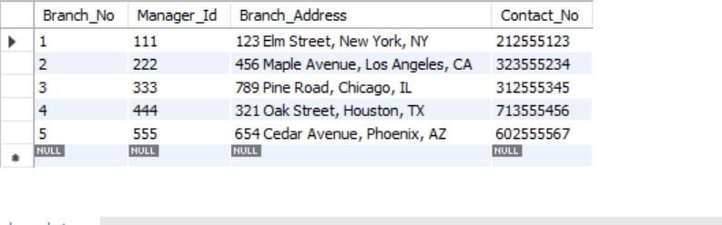

**BOOKS TABLE**:

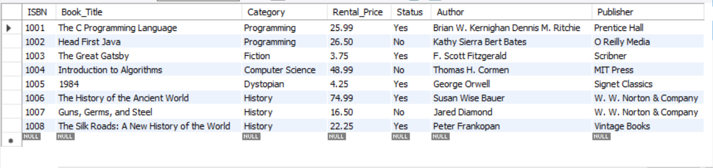

**CUSTOMER TABLE :**

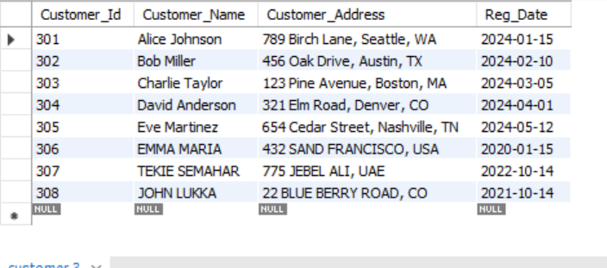

**EMPLOYEE TABLE :**

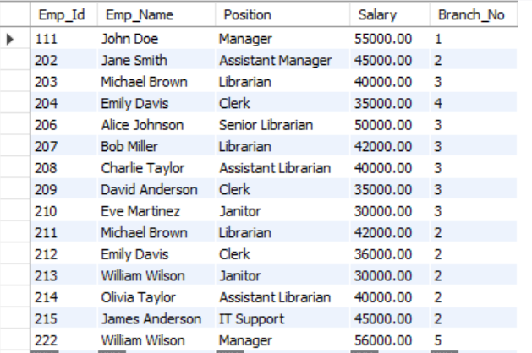

**ISSUE_STATUS TABLE :**

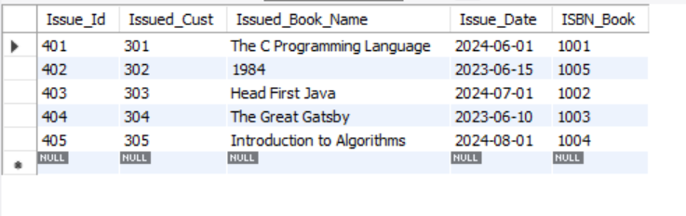

**RETURN_STATUS TABLE :**

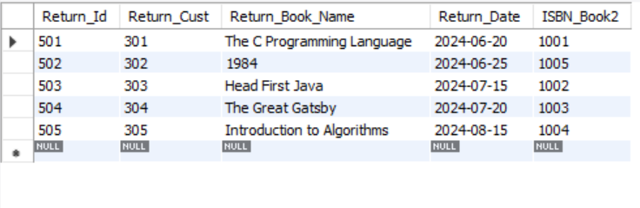

Q1. Retrieve the book title, category, and rental price of all available books.

select Book_Title, category,Rental_Price from Books ;

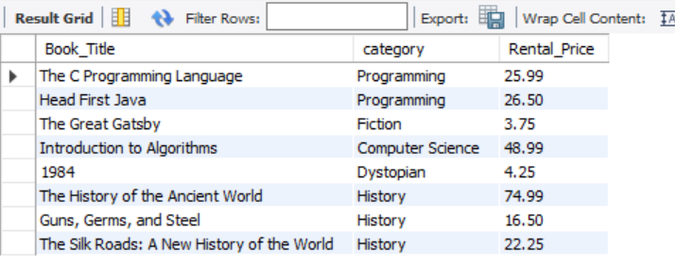

Q2. List the employee names and their respective salaries in descending order of salary.

select Salary,Emp_Name from employee order by salary desc;

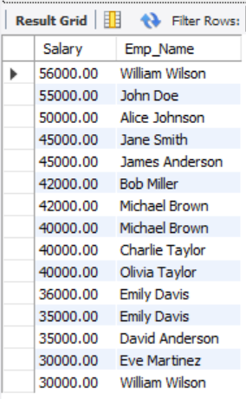

Q3. Retrieve the book titles and the corresponding customers who have issued those books.

select books.Book_Title ,customer.Customer_Name from issuestatus

join books on issuestatus.ISBN_Book=books.ISBN

join customer on issuestatus.issued_Cust=customer.customer_id;

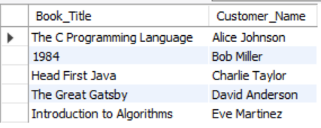

Q4. Display the total count of books in each category.

select Category,count(Book_Title) from books group by Category;

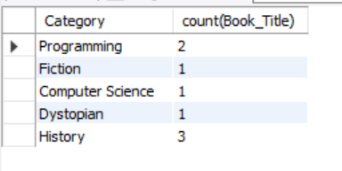

Q5. Retrieve the employee names and their positions for the employees whose salaries are above Rs.50,000.

select Emp_Name,Position from employee where Salary>50000;

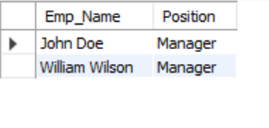

Q6. List the customer names who registered before 2022-01-01 and have not issued any books yet.

select Customer_Name from customer where Reg_Date < "2022-01-01";

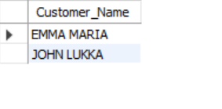

 Q7. Display the branch numbers and the total count of employees in each branch.

select Branch_No,count(*) as Total_Emp

from employee

group by Branch_No;

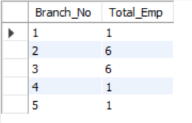

Q8. Display the names of customers who have issued books in the month of June 2023.

select customer.Customer_Name

from customer INNER JOIN issuestatus

on customer.Customer_Id=issuestatus.Issued_Cust

where Issue_Date between "2023-06-01" and "2023-06-30";

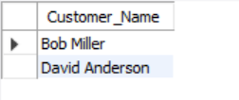

 Q9. Retrieve book_title from book table containing history.

select Book_Title from books where Category = "history";

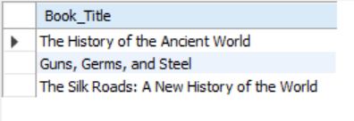

Q10. Retrieve the branch numbers along with the count of employees for branches having more than 5 employees.

select Branch_No,count(*) as count

from employee

group by Branch_No having count(*)>5;

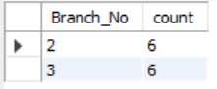

Q11. Retrieve the names of employees who manage branches and their respective branch addresses.

select employee.Emp_Name ,branch.Branch_Address from employee inner join branch on employee.Emp_id=branch.Manager_Id;

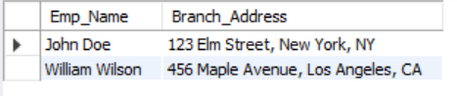

Q12. Display the names of customers who have issued books with a rental price higher than Rs. 25.

select distinct Customer_Name from customer inner join issuestatus on customer.Customer_Id=issuestatus.Issued_Cust join books on issuestatus.ISBN_Book=books.isbn

where books.Rental_Price>25;

